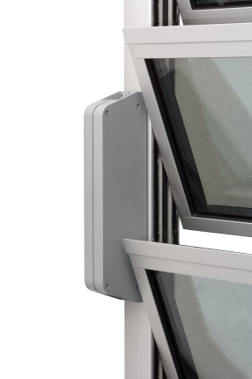

E-Motor D+H LAH 65 / 24V or LAH 65 K / 230 V (BSY)
incl. 2,5 m cable (similar RAL 7035), without switch, temperature range -20°C to +70°C, motor housing coated in RAL similar vent frame (lacquer coated), with electrical end- or overload switch off, power reduction adjustable, mounted on window frame

